Comparative Study of Manufactured Sand & natural sand

T.LOKESH
DCE II year IV SEM
DEPARTMENT OF CIVIL ENGINEERING
SREE VISVESVARAYA INSTITUTE OF TECHNOLOGY AND SCIENCE

P.BHARATHI
DCE II year IV SEM
DEPARTMENT OF CIVIL ENGINEERING
SREE VISVESVARAYA INSTITUTE OF TECHNOLOGY AND SCIENCE

Abstract

The present research work enables us to study the basic properties of concrete in which Manufactured Sand (M-Sand) is used as a partial and full replacement for natural sand. To retain the natural resource such as natural sand an attempt is made in this research by partially replacing the natural sand with M-Sand. To study the basic strength and durability characteristics of concrete, M30, M40 and M50 grades were selected. In the strength characteristic study, the compressive strength, split tensile strength and flexural strength were determined experimentally for the conventional and M-Sand concrete. In the durability study, the conventional and M-sand concrete is tested by conducting acid attack test, sulphate

attack test and Rapid Chloride Permeability Test(RCPT).The experimental results revealed that the M-Sand replaced concrete have 20% more compressive strength when compared with conventional concrete for the 60% replacement of sand with M-sand (which found optimum). In the acid attack test, the percentage weight loss for conventional concrete is 2.65%, whereas for M-sand replaced concrete it is only 2% irrespective of grade of concrete. Low chloride ion permeability was observed for M-Sand concrete whereas moderate chloride ion permeability was observed for conventional concrete in RCPT test. The test results exhibits that the durability property of concrete is enhanced by partial replacement of sand with 60% of M-Sand for all the grades of concrete.

1. Introduction

The use of Manufactured sand (M-sand) has been increasing due to the scarcity of good quality natural river sand. Manufactured sand is generally produced by feeding stones of varying sizes into VSI crusher to undergo crushing process, to achieve excellent quality and consistent gradation. M-sand produced from the above process are generally more angular and they have a rougher surface texture. This M-sand has been well defined in IS 383-1970 under clause 20. M-sand after undergoing the crushing process, are washed away in sand trap to remove the fines. This washing facility reduces the absorption rate of M-sand. With this well designed washing and screening process the required grading (zone II) and fineness modulus of (2.4 to 3.1) can be achieved.

Thus properly processed M-sand can be used in concrete manufacturing to improve the mechanical and durability properties through better bond when compared to river sand.

The formation history of sand determines their particle shape. Natural sand tends to be round due to the cumulative effect of multiple collisions and abrasion. Manufactured sand are the product of rock crushing, which creates grains with distinctive particle shapes that depend on the parent rock composition fracture mode coordination number during crushing and the reduction ratio. The crushing process tends to produce angular sharp edged particles. Rough angular particles yield a granular packing of lower density, lower small strain stiffness and higher critical state friction angle when compared with more rounded natural sand1. In M-sand

these fines usually are most likely smaller size fractions of crushed aggregate, while in natural sands the fines can be clays or other deleterious particles. Generally, the fines are composed of rock dust rather than the silts and clays in the case of natural sands. As per ASTM -C 33 the maximum permissible limit of M-sand fines passing through 75µm sieve is 7%2and the limit proposed for M sand fines passing through 150 µm sieve as per the Indian standards is 20%3. Due to the presence of high fines content, the M sand has a significant influence on the water demand and the workability of the mortar4. Other sand characteristics such as mineralogy, particle shape, and surface texture are not necessarily measured by typical tests. Yet, they may strongly influence overall performance5. Hence there is a need for the extensive investigations of the mechanical and durability behaviour of M-sand replaced concrete.

In6 investigated the compressive strength and flexure strength of concrete by partially replacing silica fume for cement and M-sand for fine aggregate. In their research work they found that the compressive and flexure strength are improved by partial replacement of silica fume for cement and M-sand for fine aggregate. They concluded that the optimum percentage of replacement of natural sand by M-sand is 50%6. In7 investigated the behaviour of concrete due to addition of steel fibre to natural sand concrete and manufactured sand concrete. They concluded that the addition of steel fibres increased the flexural and split tensile strength consistently, for both M-sand concrete and conventional concrete. The compressive strength has only a marginal hike in values for both the concrete7. In8 studied the mechanical behaviour of M30 grade nano concrete with M-sand. In this investigation, nano silica is added in place of cement by 0.75%. This nano concrete have more compressive strength and flexural strength than the M-sand concrete8. In9 experimentally investigated the compressive strength of M-sand concrete and compared with conventional concrete. The result obtained by the researchers indicates that 50% replacement of M-sand with natural sand, increases the compressive strength by 5.7% for 100% replacement of natural sand by M-sand. The flexural strength increased by 7.03%, but in this case the concrete mix becomes very harsh9. In10 studied about the addition of quarry dust as an alternative for natural sand. The addition of quarry dust increases, the strength and permeability resistance of the concrete. The compressive strength property of quarry dust replaced concrete showed significant strength enhancement to a maximum 50Mpa. They studied that compared with natural sand, 100% quarry dustreplacement in concrete showed the considerable reduction in cracked permeability and chloride permeability at higher cement content and higher F/C ratio.
The purpose of this study is to conduct a systematic comparison of the effects of natural and manufactured

2. Experimental Program

This experimental program consists of workability, strength tests and durability tests on concrete with partial replacement of river sand by M-sand. For the determination of properties at the green stage of concrete, workability, slump test has been preferred as it is more convenient for field works than any other workability test. For the evaluation of strength and durability properties of concrete with M-sand as partial replacement of river sand, tests on cubes, cylinders and prisms were adopted. The variations in this phase of study include the partial replacement of river sand by M-sand at regular intervals of 30%, 40%,50%,60%, 70% and 100% for M30, M40, and M50 grades of concrete.
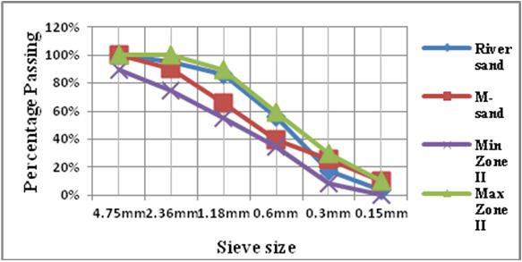

Figure 1. Sieve analysis graph.

M-sand is used as partial replacement of fine aggregate. Sieve analysis is carried out to determine the fineness modulus and to draw the grading curve of fine aggregate by sieving as per code IS 383-1970.The sieve analysis has been carried out for sand as per code IS 383-1970. The bulk density and specific gravity of manufactured sand is calculated experimentally and its value is1862 Kg/m3and 2.50 respectively.The fineness modulus of M-sand is 2.68. The percentage of particles passing through various sieve

were compared with natural sand and are presented in Table 1 and the graph was drawn for sieve analysis for the two sand.

Table 1. Sieve analysis comparison of two sand

Sieve size | River sand % | M-sand %
 | passing | passing
4.75mm | 100.00 | 100.00
2.36mm | 95.6 | 90.70
1.18mm | 86.00 | 66.20
0.6mm | 56.20 | 39.80
0.3mm | 17.70 | 25.50
0.15mm | 3.10 | 9.90
Fineness modulus | 2.30 | 2.68

Table 1 shows the fineness modulus of river sand as 2.30 whereas the fineness modulus of M-sand is 2.68. However, manufactured sand particles match the shape of river sand very closely. The sieve analysis graph (Figure 1.) shows that the river sand and M-sand lies between the maximum andminimum range of zone II of IS 383. The percentage of passing through 0.15mm sieve is less than 10%.

2.1 Experimental Investigation

The conventional concrete and M-sand concrete cubes, cylinder and beams were casted and tested.The specimens were cured for 28 days and tested, with M-sand replacement of 30%, 40%, 50%, 60%, 70%and100% for M30, M40 and M50 grades of concrete. Totally 108 cubes were casted and tested to study the mechanical and durability properties of concrete. The tests were carried out conforming to IS 516 -1959 to obtain compressive strength of concrete at the age of 28 days and the results are tabulated in Table 2.

Table 2. Compressive strength of concrete

Natural M-sand Compressive Compressive Compressive

sand | (%) | Strength | Strength | Strength
(%) |  | M30 (Mpa) | M40 (Mpa) | M50 (Mpa)
100 | 0 | 36.12 | 46.80 | 54.34
70 | 30 | 38.27 | 48.51 | 56.87
60 | 40 | 41.24 | 51.26 | 58.24
50 | 50 | 44.36 | 53.08 | 61.12
40 | 60 | 47.20 | 55.82 | 64.32
30 | 70 | 45.67 | 52.24 | 62.36
0 | 100 | 42.64 | 50.22 | 60.26

Figure 2. Compressive strength of concrete Vs.
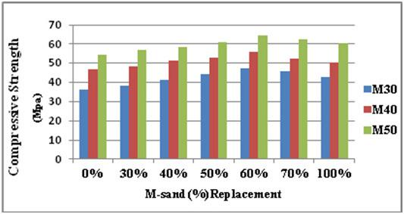
M-sand replacement.

2.1.1 Compressive Strength

Table 2 shows that there is an increase in the compressive strength of concrete up to 60% replacement of M-sand with river sand. Further addition causes reduction in the strength. Figure 2 shows that for M30 grade concrete, the compressive strength increased by 30% for 60% replacement of M-sand compared with conventional concrete, whereas for M40 grade concrete, the compressive strength of M-sand replaced concrete have 19% more strength than conventional concrete. For the M50 grade concrete, it is increased only by 18% for M-sand replaced concrete when compared with conventional concrete. This increase in compressive strength is observed due to denser particle packing and the silt free nature of M-sand concrete. Hence the optimum percentage replacement of M-sand is designated as 60%.

2.1.2 Split Tensile Strength

Splitting tensile strength is an indirect method used for determining the tensile strength of concrete. Split Tensile strength was measured using a compression testing machine with maximum capacity of 2000 KN.Tests are carried out on 150mmх300mm cylinders conforming to IS 5816: 1976 to obtain the splitting tensile strengths at the age of 28 days. The splitting tensile test is carried out by placing the cured concrete cylinders with its axis horizontal, between plates of the testing machine, and the load is increased until the failure occurred by splitting in the plane containing the vertical diameter of the specimen. The magnitudes of the tensile stress is given by 2P/πDL, were P is the applied load and D, L, are the diameter, length of the cylinder respectively.

The cylinders were casted, cured and tested using compression testing machine. For conducting split tensile strength, 63 cylinders were casted and cured and the testing was carried out to obtain the 28 days strength with partial replacement of M-sand. The obtained results were critically analyzed and are presented.

Table 3. Split tensile strength of concrete

Natural | M-sand | Split | Split | Split
sand | (%) | Tensile | Tensile | Tensile
(%) |  | Strength | Strength | Strength
 |  | M30 (Mpa) | M40 (Mpa) | M50 (Mpa)
100 | 0 | 3.66 | 4.05 | 5.20
70 | 30 | 3.79 | 4.20 | 5.23
60 | 40 | 4.05 | 4.36 | 5.34
50 | 50 | 4.10 | 4.56 | 5.56
40 | 60 | 4.71 | 4.87 | 5.68
30 | 70 | 4.47 | 4.74 | 5.59
0 | 100 | 3.68 | 4.63 | 5.48
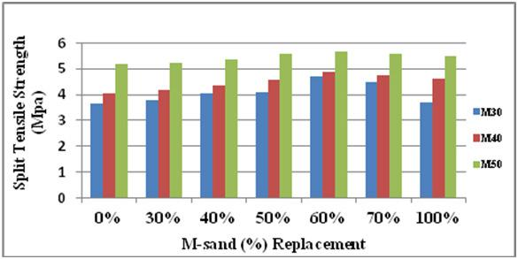

concludes that there exists a similar trend in the flexural behaviour also, while replacing M-sand with river sand.

Table 4. Flexural strength of concrete

Natural | M-sand | Flexural | Flexural | Flexural
sand | (%) | Strength | Strength | Strength
- M30 (Mpa) M40 (Mpa) M50 (Mpa)

100 | 0 | 4.15 | 4.99 | 6.23
70 | 30 | 4.23 | 5.20 | 6.48
60 | 40 | 4.36 | 5.36 | 6.69
50 | 50 | 4.50 | 5.58 | 6.82
40 | 60 | 4.78 | 5.72 | 7.03
30 | 70 | 4.52 | 5.48 | 6.73
0 | 100 | 4.28 | 5.26 | 6.54
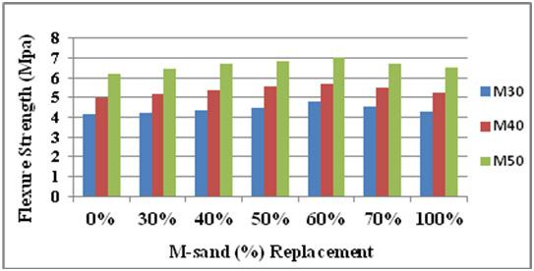

Figure 3. Split tensile strength of concrete Vs.

M-sand replacement.

From the Table 3 it is well defined that the split tensile strength increases up to 60% replacement with M-sand. Beyond 60% replacement, the split tensile strength decreases. It can be inferred from the Figure 3 that the split tensile strength increased by 28% for M30 grade concrete, 20% for M40 grade concrete and 9% for M50 for 60% replacement of M-sand with river sand. The graph implies that there is decrease in split tensile strength beyond 60% replacement of M-sand with river sand. There is a significant improvement in the split tensile strength of concrete up to 60% replacement with M-sand.

2.1.3 Flexural Strength Test

The test was carried out conforming to IS 516-1959 to obtain the flexural strength of concrete at the age of 28 days. The beams were tested using flexure testing machine. The results obtained were systematically analyzed and it

Figure 4. Flexural strength of concrete Vs. M-sand replacement.

Table 4 shows that the flexural strength increased up to 60% replacement of river sand with M-sand. Above 60% the flexural strength decreased. The tabulated results and the graph showed the same trend in the flexural strength behaviour of concrete with 60% replacement.

The Figure 4 clearly illustrates that the flexural strength increased by 15% for M30 grade concrete for 60% replacement of river sand with M-sand whereas for M40 grade concrete the percentage increase is 14%. For the M50 grade concrete, it is increased only by 12% for 60% replacement of M-sand concrete when compared with conventional concrete.

- Experimental Investigation on the Durability Behaviour of Concrete

Specifying a durable concrete begins with identifying exposure conditions. Durability of concrete is its ability

to perform satisfactorily in the exposure condition to which it is subjected over an intended period of time with minimum maintenance. The environment in which the concrete is exposed plays an important role in the durability. The experimental investigation consists of two phases. The first phase of the investigation involved the optimisation of M-sand replacement. The second phase deals with the durability of concretewhichincludes acid attack, and sulphate attack.

3.1 Acid Attack Test

The acid resistivity of concrete was studied by immersing the specimens in acid solution. The test has been conducted for the conventional concrete and concrete specimens replacing fine aggregate with 60% of M-sand. The specimens of size 150x 150 x150mm were casted and cured in water for 28 days. After 28 days of curing the specimens were removed from the curing tankand their surfaces were cleaned with a soft nylon brush to remove weak reaction products and loose materials from the specimen. The initial weights were measured and the specimens were immersed in 5% sulphuric acid solution for the next 28 days of acid exposure, specimens were tested for compressive strength and compared with the strength of concrete specimens which were not exposed to acid attack. The results are tabulated.

Table 5. Weight loss and compressive strength loss

Mix | M-sand | Weight loss | Compressive
designation | (%) | (%) | strength loss(%)
M30 | 0% | 2.65 | 9.73
M30 | 60% | 2.36 | 9.54
M40 | 0% | 2.46 | 8.49
M40 | 60% | 2.25 | 8.31
M50 | 0% | 2.23 | 8.08
M50 | 60% | 2.09 | 7.98
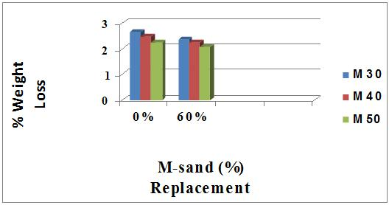

Figure 5. Weight loss under acid attack

Table 5 shows that the percentage weight loss and the compressive strength loss due to acid attack after 28 days of curing in sulphuric acid. For concrete samples with 100% natural sand, the weight loss and the compressive strength loss is more than that for concrete samples with 60% Manufactured sand.

Figure 5 shows that M50 grade of concrete shows the least weight loss % and compression strength loss among other grades of concrete in which, M50 with 60% replacement of fine aggregate with M-sand shows more resistance to acid attack when compared to the conventional concrete.

3.2 Sulphate Attack Test

The sulphate resistivity of concrete was studied by immersing the specimens in sulphate solution. The test has been conducted using conventional concrete and concrete specimens replacing fine aggregate with 60% of M-sand. The specimens of size 150x150x150mm werecasted and cured in water for 28 days. After 28 days of curing the specimens were removed from the curing tank and their surfaces were cleaned with a soft nylon brush to remove weak reaction products and loose materials from the specimen. The initial weights were measured and the specimens were immersed in 5% sodium sulphate solution for the next 28 days of sulphate exposure, specimens were tested for compressive strength and compared with the strength of concrete specimens which were not exposed to acid environment.

Table 6. Weight loss and compressive strength loss

Mix | M-sand | Weight | Compressive
Designation | (%) | loss (%) | strength loss (%)
M30 | 0% | 1.78 | 6.98
M30 | 60% | 1.60 | 6.74
M40 | 0% | 1.55 | 5.45
M40 | 60% | 1.40 | 5.21
M50 | 0% | 1.12 | 4.87
M50 | 60% | 0.97 | 4.31
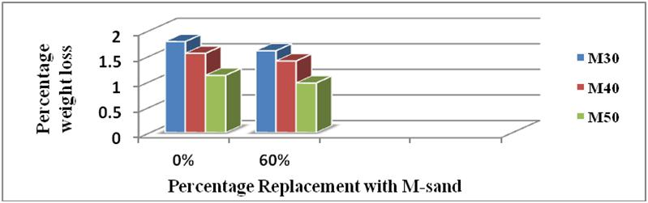

Figure 6. Weight loss under sulphate attack.

Table 6 shows that the percentage weight loss and the compressive strength loss due to sulphate attack after 28 days of curing in sulphate solution. For concrete samples with 100% natural sand, the weight loss and compressive strength loss are slightly more than that for concrete samples with 60% manufactured sand.

Figure 6 clearly indicates that M50 grade of concrete shows the leastweight loss % and the compression strength loss percentage among the other grades of concrete in which, M50 with 60% replacement of fine aggregate with M-sand shows more resistance to sulphates when compared with conventional concrete. The percentage weight loss due to sulphate attack is 1.8 % for conventional concrete and 1% for M-sand replaced concrete. Hence the M-sand concrete have good resistance against sulphate attack.

3.3 Rapid Chloride Permeability Test

Chloride penetration in concrete is mainly affected for concrete structures subjected to sea water or ground water environment containing high concentration of chloride salts dissolved in it. The RCPT is an indication of the permeability of chloride ions in the concrete. The rapid chloride penetration test was conducted as per ASTMC 1202-1997.

Table 7. Rapid chloride permeability values

Mix | (%) | Charge passed | Chloride
Designation | replacement | in coulombs | permeability
M30 | 0% | 2887.15 | Moderate
M30 | 60% | 1989 | Low
M40 | 0% | 2850 | Moderate
M40 | 60% | 1855.9 | Low
M50 | 0% | 2020.05 | Moderate
M50 | 60% | 1810 | Low
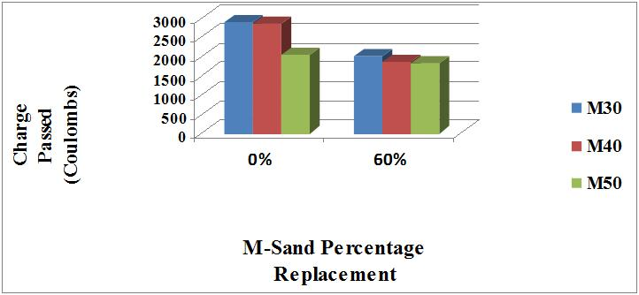

Figure 7. Rapid chloride permeability chart.

Table 7 shows that the chloride permeability for conventional concrete is moderate whereas for M-sand

replaced concrete the permeability is low.

The Figure 7 reveals that M50 grade shows lower permeability when compared to M40 and M30 for conventional concrete and concrete with partial replacement of M-sand. Thus it can be said that with lower w/c ratio and higher quantity of coarse aggregate the chloride penetration is decreased.

4. Conclusion

The results of the present research work concludes that the compressive strength, split tensile strength and flexure strength of concrete is significantly improved by partial replacement of M-sand for fine aggregate.

- It is observed from the experimental results that, the M-sand replaced concrete have 30% more compressive strength for M30 grade,19% more compressive strength for M40 grade and 18% more strength for M50 grade concrete up to 60% replacement of M-sand and further increase in the percentage of M-sand showed reduced the strength.

- The experimental results proved that the split tensile strength of concrete increased by 28%, 20% and 9% for M30, M40 and M50 grade concrete, when compared with conventional concrete up to 60% replacement of M-sand with river sand.
- The Flexure strength of concrete increased by 15% for M30 grade, 14% for M40 grade and 12% for M50 grade concrete up to 60% replacement of M-sand with river sand.When the percentage of replacement of M-sand goes beyond 60%, the strength is considerably reduced.

- The percentage weight loss due to sulphate attack is 1.8% for conventional concrete and 1% for M-sand replaced concrete irrespective of the grade of concrete. The percentage weight loss due to acid attack is 2.65% for conventional concrete and 2% for M-sand replaced concrete.

- The durability of M-sand concrete under acid and sulphate attack is higher inferior to that of conventional concrete.
- The RCPT test results reveals that M50 grade concrete shows lower permeability when compared to M40 and M30 for conventional concrete and concrete with partial replacement of M-sand.
- Hence this research work concludes that, M-sand can be used as an alternative material for river sand and thereby the sustainability can be achieved.

